

Annual Assessment Report for Academic Progrms – revised 2025

The University Assessment Team advocates for the enhancement of student learning through purposeful, meaningful, and feasible student-outcomes assessment practices. The Assessment Team seeks to collaborate with programs, departments, and units to ensure that effective assessment of student learning occurs across the University. To assist in meeting this goal, the Team requests that you complete this Annual Assessment Report form to document student learning in your program. A PDF version of this completed form will be posted to the Academic Affairs Assessment website.
Please note that this Annual Assessment Report form should only be completed after you have an Assessment Plan for Academic Programs on file with the University Assessment Team. The plan is completed once and only updated when revisions have been made to components of the plan.

- Degree Level and Program Name (e.g. BA History, MS Physician Assistant, JD Law, DDS Doctor of Dental Surgery):

- College/School

- Assessment Overview
Briefly share how student learning outcomes assessment is conducted within your program/department. Be sure to include:
- number of outcomes,
- frequency of assessment, and
- examples of assignments used
Limit is 100 words.
Example: Assessment Overview
The BS Cybersecurity program has four student learning outcomes, with two outcomes assessed each year. Faculty assess student learning outcomes using direct measures from embedded assignments: hands-on technical lab, exams, design cases, and projects using rubrics

- Student Learning Outcomes & Benchmarks
Which student learning outcome(s) from the assessment plan filed with the University Assessment Team is/are being reported on in this report? Include the corresponding benchmark(s) for each outcome.
Example: Student Learning Outcomes & Benchmarks -
Student Learning Outcome #1: Analyze a problem and identify and define the security risks and requirements appropriate to its solution. Benchmark for SLO #1 - at least 75% of the students earn a rubric equivalate total score of C or better on the hands-on lab assignment.
Student Learning Outcome #2: Demonstrate the use of techniques, skills, and tools necessary for cyber defense within an organization. Benchmark for SLO #2 - at least 75% of the students earn a rubric equivalate total score of C or better on the hands-on lab assignment.

- Alignment with Institutional Outcomes: For which institutional outcome(s) do the reported student learning outcome(s) align? Select all that apply.
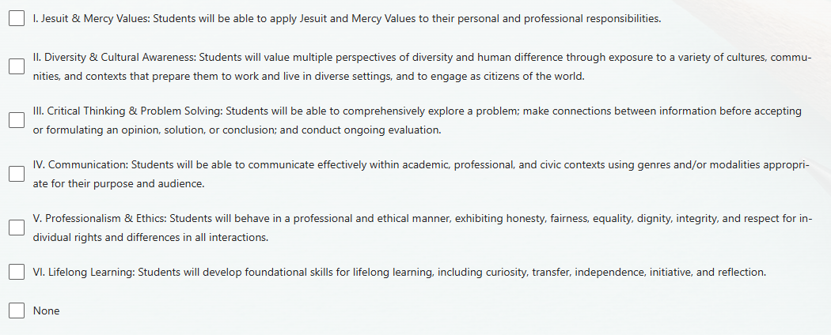

- Assessment Period: Select the academic year for which you are reporting results (e.g. when data were collected):
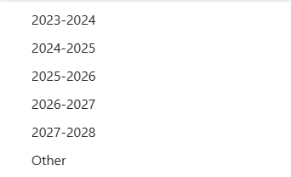

- Program Assessment Results - Briefly summarize the assessment results and how they relate to benchmark(s). Limit is 100 words.
Example of Program Assessment Results –
Outcome #1: 83% (10/12) of the CIS 3850, Cybersecurity Risk Management students earned a rubric equivalent score of C or better on the hands-on lab assignment, which is above the 75% benchmark for the group of students. The aggregate mean rubric scores (using a 4-point scale) indicated students’ strengths were in Identification of cybersecurity risk to the organization (3.33) and Respond-taking action regarding a detected cybersecurity incident (3.21). Students’ opportunities for improvement were in Detecting all of the critical pieces of information (3.04).
Outcome #2: 80% (8/10) of the CIS 4450 Introduction to Digital Forensic students earned a rubric equivalent score of C or better on the Network Traffic Analysis with Wireshark hands-on lab, which is above the 75% benchmark for the group of students. The aggregate mean rubric scores (using a 3.5-point scale) indicated students’ strengths were in downloading and installing a cybersecurity network scanning tool (2.75) and interpreting Wireshark packets, queries, and pcap information (2.6). Students' opportunities for improvement include interpreting more in-depth packet scanning information (2.55).

- Planned Actions and/or Actions Taken in Response to Assessment Results
Briefly summarize how you are using the assessment results to enhance student learning and improve program quality. Limit is 100 words.
Example: Planned Actions and/or Actions Taken in Response to Assessment Results -
In response to the assessment results, the department reviewed and revised instructional materials and assignments to improve student competencies in the identified areas.

- Before submitting this form please review the current assessment plan for your program to ensure alignment of outcomes with current professional and/or accrediting standards.
