Job Hazard Analysis

Task/Equipment: | Fluid Change for Control Compressor
Department: | Powerhouse
Analyzed By: | Bill Partin and Bryana Borders
Date: | 4/16/19

Personal Protective Equipment Required:




Heavy Leather Gloves
Splash Goggles
Hard Hat

Trainings Required*/Recommended:

Lock out tag out*

Equipment/Tools/Chemicals Required for the Job:

Compressor fluid, air filter, socket wrench, screw driver, filter wrenches, hand tools, funnel, oil/fluid absorbing compound
Steps | Hazards Present | Safety Measures and Controls
- Start standby compressor | No hazards present | N/A
- check to insure water flow to drain from water-cooled standby compressor or cooling fan is running for air cooled compressor | Finger cuts and water splash-back into eyes | Wear heavy leather gloves and splash goggles
- Push stop button on control pad to stop compressor being serviced | No hazards present | N/A
- Open main power disconnect at 3-phase distribution panel and secure using lock-out tag-out protocol | Skipping this step could cause severe burns to skin and eyes in step 6 | Follow lockout tag out protocol
- Isolate the compressor pneumatically and relieve system of air pressure until control panel pressure indicator reads zero | Skipping this step could cause severe burns to skin and eyes in step 6 | Control panel is there to show the current pressure. Wait until that hits zero before moving on to the next step.
- Remove fill tube cap | Skin burns, eye and facial injury | Close and secure pneumatic pressure isolation valve using lock-out protocol .Verify that all system pressure has been dissipated before opening system to service. Wear safety googles and heavy leather gloves
- Open drain valve and remove plug , Allow reservoir to drain completely | Skin burns | Wear heavy gloves
- Replace drain plug and close drain valve | No hazards present | N/A
- Fill fluid reservoir with fresh fluid to proper level | No hazards present | N/A
- Replace reservoir fill-cap and secure | No hazards present | N/A
- Reopen pneumatic isolation valve | No hazards present | N/A

Additional Information:

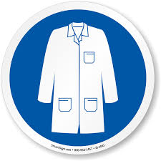
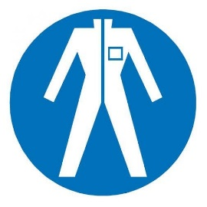
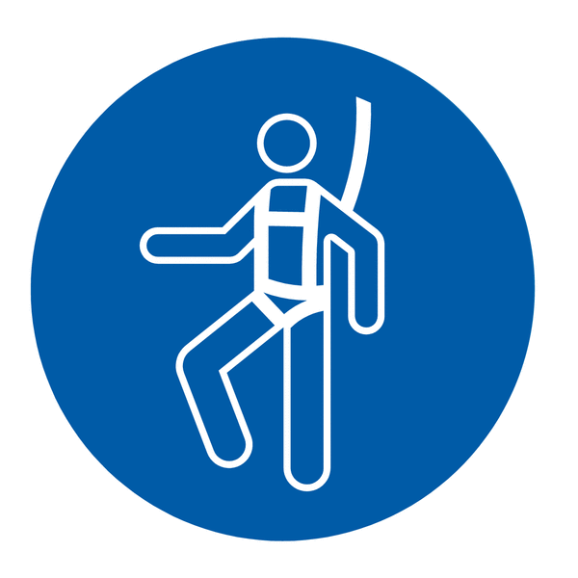

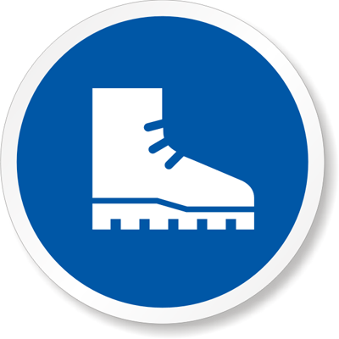


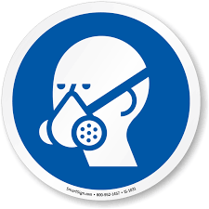



Lab Coat
Protection Suit
Fall Protection Harness
High Vis Vest
Safety Shoes
Cryogenic Gloves
Dust Mask
Respirator
Face Shield
Safety Glasses
Ear Protection

