Job Hazard Analysis

Task/Equipment: | Reassembling Summer Boiler After Inspection
Department: | Powerhouse
Analyzed By: | Bill Partin & Bryana Borders
Date: | 4/12/19

Personal Protective Equipment Required:



Hard Hat
Heavy Leather Gloves

Trainings Required*/Recommended:

Ladder Training*, OSHA 10

Equipment/Tools/Chemicals Required for the Job:

Screw driver, hand tools, socket wrenches, hammer, ladder, Pipe wrenches, anti-seize compound, flash light, flood light
Tasks/Steps | Hazards Present | Safety Measures and Controls
- Replace manway covers (may need to use a hammer) and install new gaskets | Finger pinch and finger/hand could be smashed by the hammer | Wear heavy leather gloves to protect fingers from being pinched. Keep hands and fingers away from blunt force from the hammer
- Reinstall all inspection tees and plugs with thin coat of anti-seize compound | No hazards present | N/A
- Reinstall both low water cutouts with new gaskets if necessary | No hazards present | N/A
- Re-enable chemical feed pump if applicable | No hazards present | N/A
- Open main stop/non return | Ladder fall | Use proper ladder protocol
- Close main disconnect after boiler is filled for service | No hazards present | N/A

Additional Information:

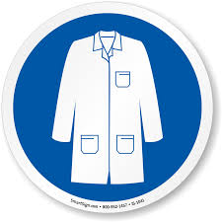
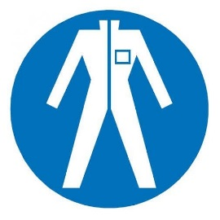
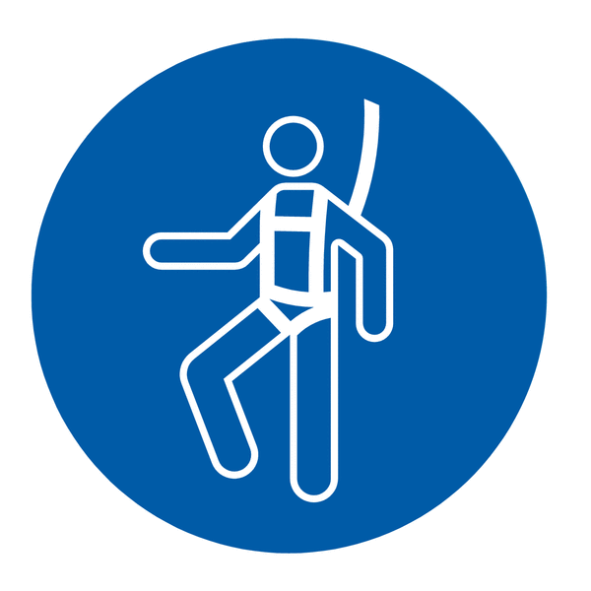

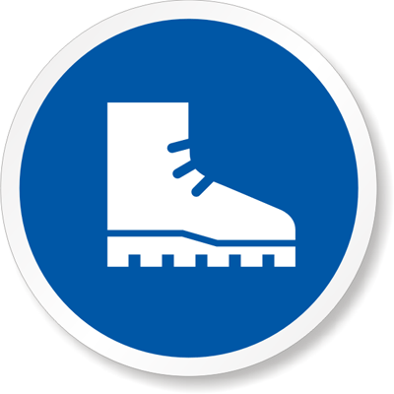



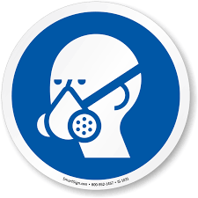



Lab Coat
Protection Suit
Fall Protection Harness
High Vis Vest
Safety Shoes
Splash Goggles
Cryogenic Gloves
Dust Mask
Respirator
Face Shield
Safety Glasses
Ear Protection

