Job Hazard Analysis

Task/Equipment: | Descaling Tower Nozzles
Department: | Powerhouse
Analyzed By: | Bill Partin & Bryana Borders
Date: | 4/12/19
Personal Protective Equipment Required:

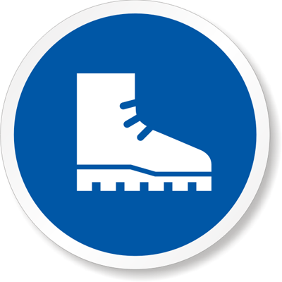
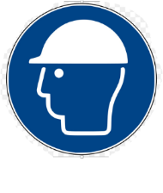
Rubber Boots
Hard Hat


Light Leather Gloves

Trainings Required*/Recommended:

Ladder safety*, confined spaces training*, lock out tag out training*

Equipment/Tools/Chemicals Required for the Job:

Hand tools, screw driver, chipping tool
Steps | Hazards Present | Safety Measures and Controls
- Turn off tower controls at main control center MCC panel using lock out tag out protocol | If tower controls are not turned off and locked out/tagged out it could cause serious injury in steps 4-7 | Second person must verify correct disconnects are locked out and tagged out
- Open main power disconnects at tower and secure using lock out protocol | If power is not disconnected and locked out/tagged out, it may result in serious injury in steps 4-7 | Second person must verify correct disconnects are locked out and tagged out
- Climb tower ladder, open entrance doors and enter tower confined space | Fall from ladder | Ladder Safety Training
- Remove upper horizontal tower fill to expose nozzles | Decapitation, severe head trauma due to fans starting unexpectedly | Lock out and tag out fan power disconnect, post second person to be sure no one enables tower fans , use confined spaces protocol
- Start condenser pumps to provide water flow | Decapitation, severe head trauma due to fans starting unexpectedly | Lock out and tag out fan power disconnect, post second person to be sure no one enables tower fans
- Use chipping tool to loosen and free scale from nozzles | Decapitation, severe head trauma due to fans starting unexpectedly; cuts from chipping tool | Lock out and tag out fan power disconnect, post second person to be sure no one enables tower fans; Use leather gloves to prevent cuts
- Replace upper fill | Decapitation, severe head trauma due to fans starting unexpectedly | Lock out and tag out fan power disconnect, post second person to be sure no one enables tower fans , use confined spaces protocol
- Exit confined space and close access doors and secure | Fall from ladder | Ladder Safety Training

Additional Information:

- Two-person Task

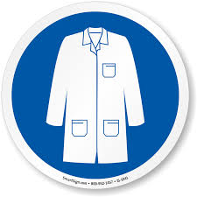
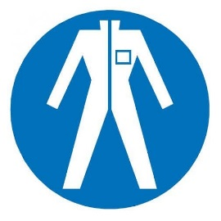
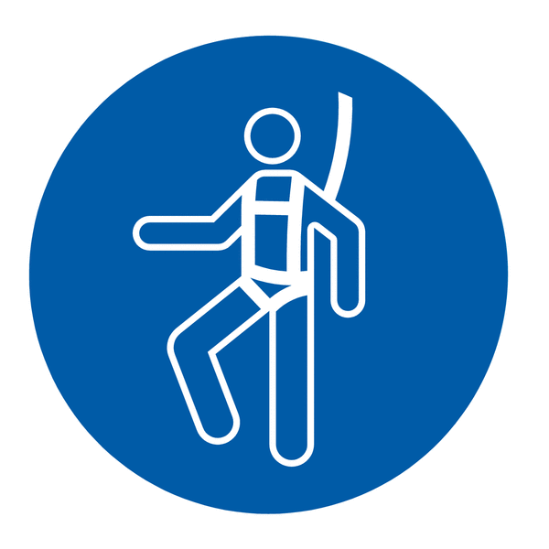
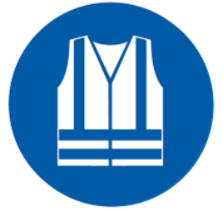
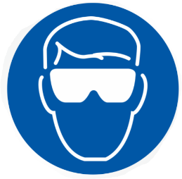
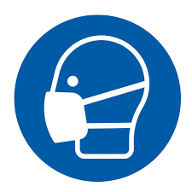
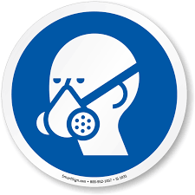
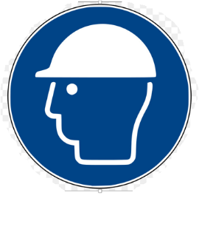

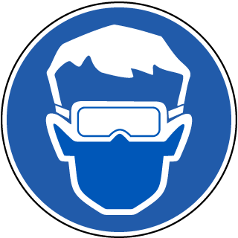

Lab Coat
Protection Suit
Fall Protection Harness
High Vis Vest
Splash Goggles
Dust Mask
Respirator
Hard Hat
Face Shield
Safety Glasses
Ear Protection

