Job Hazard Analysis

Task/Equipment: | Cleaning Suction Strainers
Department: | Powerhouse
Analyzed By: | Bill Partin & Bryana Borders
Date: | 4/12/19
Personal Protective Equipment Required:


Heavy Leather Gloves

Hard Hat

Trainings Required*/Recommended:

Proper use of impact tool*, OSHA 10

Equipment/Tools/Chemicals Required for the Job:

Socket wrenches, hand wrenches and rotary impact tool

Tasks/Steps | Hazards Present | Safety Measures and Controls
- Turn off pump at control panel | No hazards present | N/A
- Isolate strainers by closing suction and discharge stop valves | No hazards present | N/A
- Connect a hose to strainer blow down tap and run to floor drain | No hazards present | N/A
- Open drain valve and allow strainer cavity to drain and cool | Skin Burn | Use heavy leather gloves and allow strainer flange to cool
- Remove bolts from strainer flange and lower flange to floor | If you use an impact tool, this could cause wrist twist | Use heavy leather gloves for grip
- Remove wire mesh strainer | Finger cuts, sharp edges | Wear heavy leather gloves to prevent cuts
- Clean strainer using soap and water | No hazards present | N/A
- Replace strainer into cavity | Finger cut, sharp edges | Use heavy leather gloves
- While one person holds flange in place the other lines up and puts bolts in place | Finger pinch | Use heavy leather gloves
- Secure bolts using socket wrench or impact tool | Wrist twist | Be careful using wrenches and impact tool, use heavy leather gloves for grip
- Close drain valve | No hazards present | N/A
- Reopen isolation valves at suction and discharge stops | No hazards present | N/A
- Turn pump on at control panel and check for leaks | No hazards present | N/A

Additional Information:

- Two Person Task

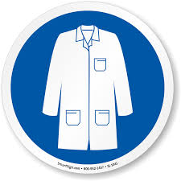
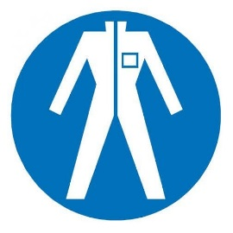
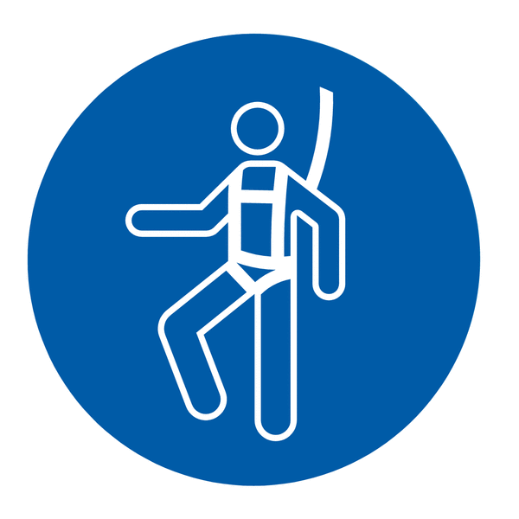
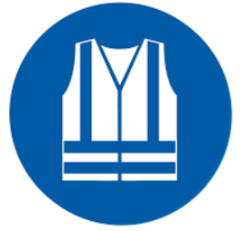
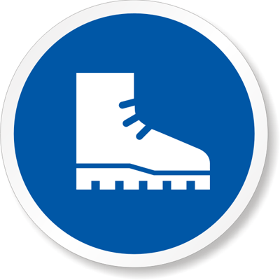



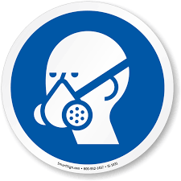



Lab Coat
Protection Suit
Fall Protection Harness
High Vis Vest
Safety Shoes
Splash Goggles
Cryogenic Gloves
Dust Mask
Respirator
Face Shield
Safety Glasses
Ear Protection

