Job Hazard Analysis
Personal Protective Equipment Required:
Task/Equipment: | Lubricating Tower Fan Bearing and Tensioning Fan Power Bands
Department: | Powerhouse
Analyzed By: | Bill Partin & Bryana Borders
Date: | 4/12/19


Hard Hat

Light Leather Gloves

Trainings Required*/Recommended:

Ladder Safety Training, Lock out tag out protocol*

Equipment/Tools/Chemicals Required for the Job:

Screw driver, tensioning wrench and grease gun
Steps | Hazards Present | Safety Measures and Controls
- Open disconnect at main control center MCC panel using lock-out tag-out protocol | Turning off wrong disconnect could cause serious injury in step 4 | Second person must verify that correct disconnect was opened and locked out
- Open main power disconnect mounted on tower structure and secure using lock-out tag-out protocol | Forgetting to open disconnect could cause serious injury in step 4 | Second person must verify that correct disconnect was opened and locked out
- Climb tower ladder and open access doors to fan compartment | Ladder fall | Ladder safety training
- Use tensioning wrench to adjust power band to desire tension | Hand loss or injury due to fans starting unexpectedly | Lock out and tag out fan power disconnects and post second person to insure that no one enables fans
- Attach grease gun hose to grease fittings and pump in grease | Ladder fall | Ladder safety training
- Close access door and secure | Ladder fall | Ladder safety training

Additional Information:

-
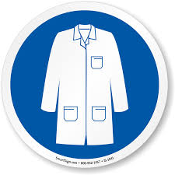
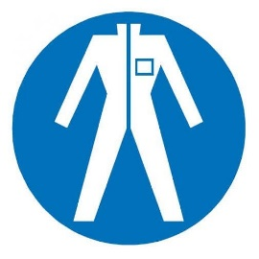
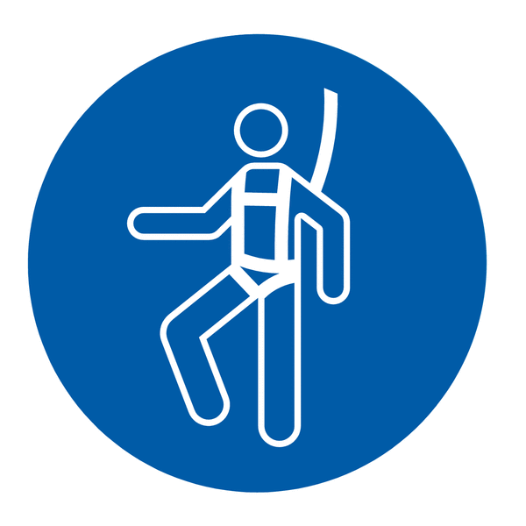
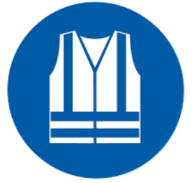
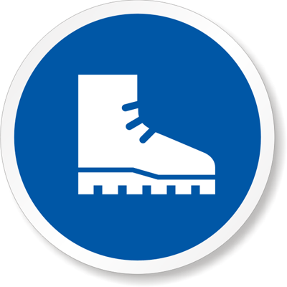




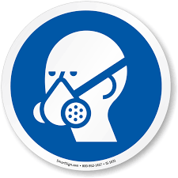




Lab Coat
Protection Suit
Fall Protection Harness
High Vis Vest
Safety Shoes
Splash Goggles
Cryogenic Gloves
Latex Gloves
Dust Mask
Respirator
Hard Hat
Face Shield
Safety Glasses
Ear Protection

