Job Hazard Analysis

Task/Equipment: | Readying Summer Boiler For Inspection
Department: | Powerhouse
Analyzed By: | Bill Partin & Bryana Borders
Date: | 4/12/19
Personal Protective Equipment Required:



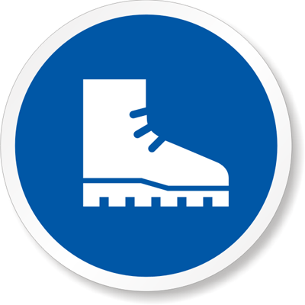
Hard Hat
Heavy Leather Gloves
Rubber Boots

Trainings Required*/Recommended:

Ladder Training, Proper Chain Fall Use*, OSHA 10

Equipment/Tools/Chemicals Required for the Job:

Pipe wrenches, hand wrenches, hammer, ladder, gloves, chain fall
Steps | Hazards Present | Safety Measures and Controls
Turn off boiler at control panel | No hazards Present | N/A
Open 3 phase power disconnect and secure using lock-out protocol | No hazards present | N/A
Close and secure feed water stop valve at front of boiler and feed water isolation valves at side of boiler and tag | No hazards present | N/A
Close main gas valves (2) and secure using lock-out protocol | Potential | N/A
Allow boiler to cool and open drum vent | No hazards present | N/A
Close non return/stop on top of boiler | Ladder fall | Follow proper ladder protocol
Close surface blow down OS&Y valve and tag | No hazards present | N/A
After boiler cools ,open blowdown valve and drain boiler | No hazards present | N/A
Remove manway covers and discard old gaskets. | Finger pinch | Wear heavy leather gloves
Remove cross tees and inspection plugs | No hazards present | N/A
Rod out all steam and water line connected to safety controls | No hazards present | N/A
Remove water level safeties and move to side | No hazards present | N/A
Clean mud drum and remove any loose scale | No hazards present | N/A
Flush tubes with power hose if needed | Slip and fall hazard from a potentially wet floor | Wear rubber boots
Reclose blowdown valves and secure using lock-out protocol | No hazards present | N/A

Additional Information:

- Two person task


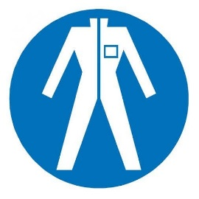
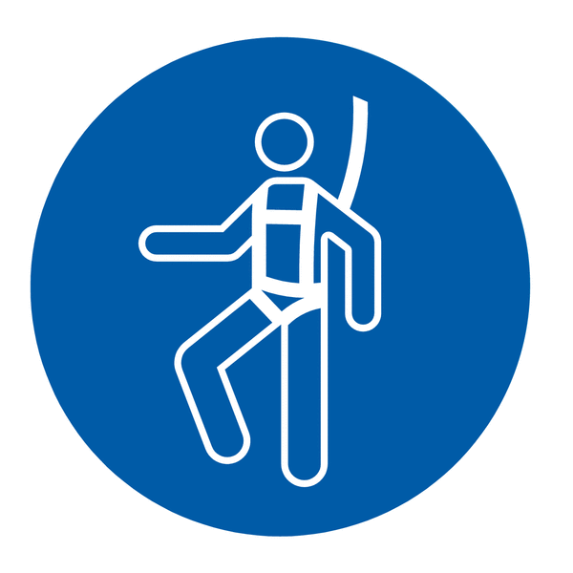
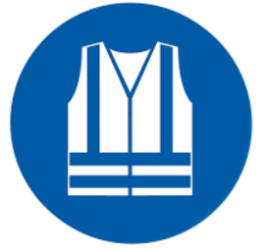


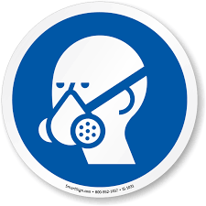



Cryogenic Gloves
Protection Suit
Fall Protection Harness
High Vis Vest
Splash Goggles
Dust Mask
Respirator
Face Shield
Safety Glasses
Ear Protection

