Completed By: Click here to enter text.
Approved By: Click here to enter text.
Department: Click here to enter text.
Issue Date: Click here to enter text.
Updated date: Click here to enter text.

Click here to enter text.
Add Hazardous Class Description if Needed

Approval/Training(s) Required

Click here to enter text.
Chemical Properties & Hazards

Chemical Properties
Click here to enter text.
Hazardss
Click here to enter text.
Personal Protective Equipment

Click here to enter text.
Engineering Controls

Click here to enter text.

Handling & Storage

Handling
Click here to enter text.
Storage
Click here to enter text.
First Aid & Spills

First Aid
Click here to enter text.

Spill
Click here to enter text.

Disposal

Click here to enter text.

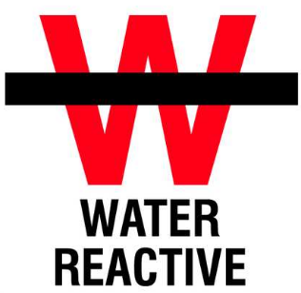
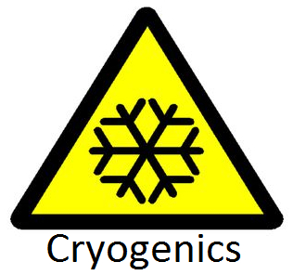
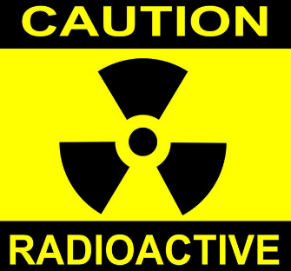
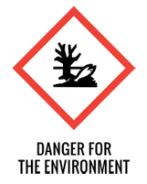
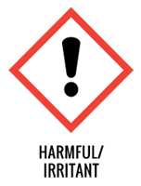
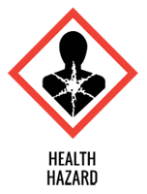
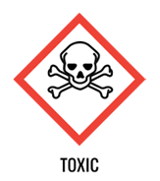
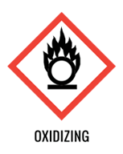
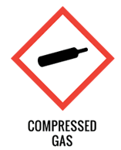
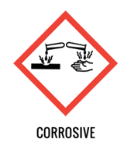
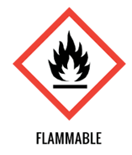
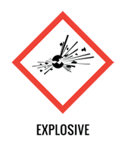







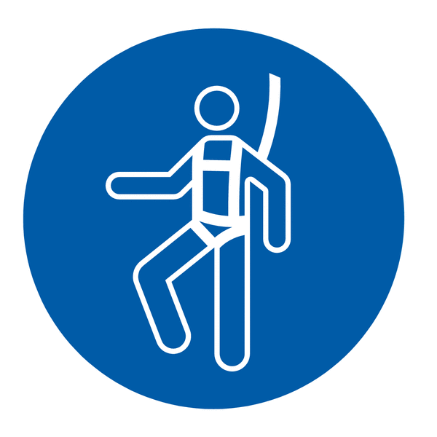

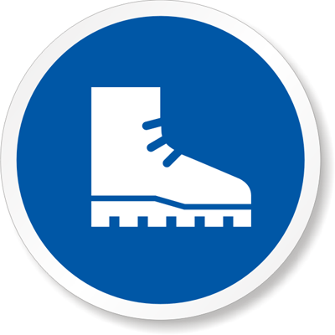


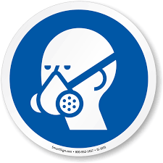

Safety Glasses
Cryogenic Gloves
Splash Goggles
Ear Protection
Face Shield Required
Lab Coat
Protection Suit
Fall Protection Harness
High Vis Vest
Safety Shoes
Latex Gloves
Dust Mask
Respirator
Hard Hat
Face Shield

